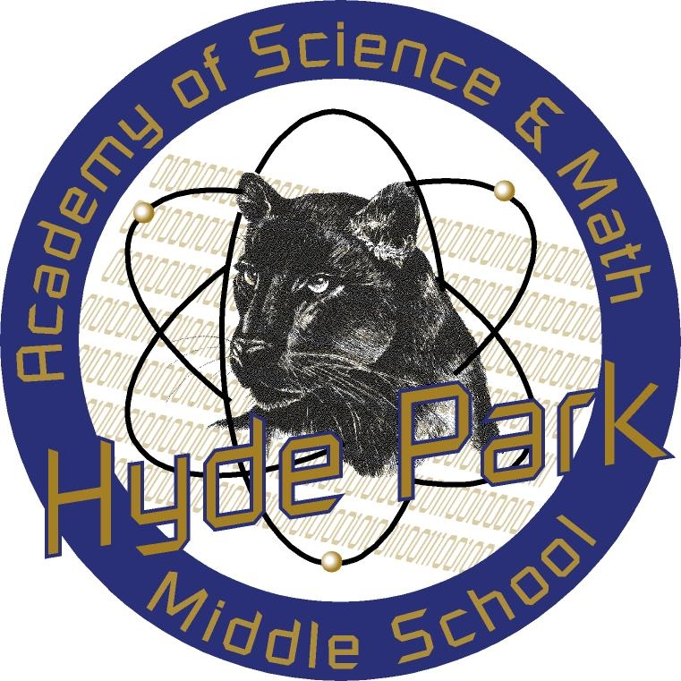
Hyde Park Middle School
Academy of Science and Mathematics
900 Hinson Street . Las Vegas . Nevada . 89107 . (702) 799-4260

______________________________________________________________________

Take Our Daughters and Sons to Work® Day
Thursday, April 25, 2019

Child’s Name: _________________________________________________________
(Print/Type Child’s Name)

Parent/Guardian’s Name:__________________________________________________
(Print/Type Parent/Guardian’s Name)

Participated in the 2019 Take Our Daughters and Sons to Work® Day at

Workplace Name:

_____________________________________________________________
(Print/Type Workplace Name)

Supervisor/Workplace Coordinator

________________________________________________________________________
(Print Name and Title)

_____________________________________________________
(Signature)

Should you need to contact me about what activities this student completed so you can build it into your classroom lessons, feel free to contact us.

___________________________________________________________________________________
Email, phone or additional contact preferences



